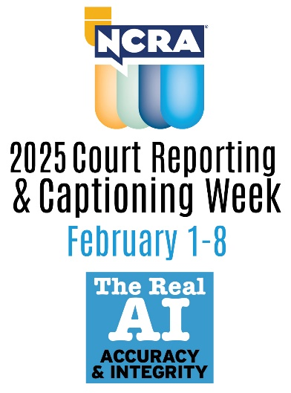
Name of Contact
Email/Phone

(Name of School) to celebrate The Real AI: Accuracy and Integrity
during 2025 National Court Reporting & Captioning Week

YOUR CITY, YOUR STATE, DATE, 2025 — The National Court Reporters Association (NCRA), the country’s leading organization representing stenographic court reporters, captioners, and legal videographers, has announced that (SCHOOL NAME highlight with link to your website) in (City, State) is promoting the career opportunities in stenographic court reporting and captioning by participating in the 2025 National Court Reporting & Captioning Week.

The weeklong event, themed “The Real AI: Accuracy & Integrity” will serve to bring court reporters, captioners, court reporting firms, schools, and others in the legal industry together to help highlight why the record produced by a human stenographic court reporter or captioner is considered the gold standard of the industry. Also to be showcased through the week will be the many aspects that make court reporting and captioning viable professions. Those aspects include a quicker entrance into the workforce since no four-year degree is required, good salaries, flexibility in schedules, interesting venues, and nearly immediate employment after graduations due to the increasing demand for more reporters and captioners in the field.

(NAME OF SCHOOL), a premier court reporting education program, is celebrating the national effort by [highlight activities, cite examples. It may be as simple as “encouraging its student population to get involved with Court Reporting & Captioning Week by engaging in a grassroots effort to promote the profession and educate local communities about the value stenographic skills bring to today’s marketplace.”]

“Provide a quote about the importance of this awareness week and the importance of this profession,” said (full name and title).

“We believe that court reporting and captioning is worthy of national recognition, and we were proud to take part in this national initiative,” said (last name of school official quoted earlier).

The 2025 event marks the 13th year NCRA has hosted the celebration.

“No matter how advanced, AI cannot replicate the human element when it comes to capturing the record,” NCRA President Keith R. Lemons, FAPR, RPR, CRR (Ret.), said.

“A live court reporter is present and has situational awareness of the emotions and innuendos of the subtlety of the spoken word, something AI cannot and will never be able to. That ability is a sacred and instinctual ability and one that no man-made system can ever replace. Stenographic court reporters and captioners are the epitome of these abilities,” Lemons said.

Court reporters and captioners rely on the latest in technology to use stenographic machines to capture the spoken word and translate it into written text in real time. These professionals work both in and out of the courtroom recording legal cases and depositions, providing live captioning of events, and assisting members of the deaf and hard-of-hearing communities with gaining access to information, entertainment, educational opportunities, and more.

If you’re looking for a career that is on the cutting-edge of technology, offers the opportunity for work at home or abroad, like to write, enjoy helping others, and are fast with your fingers, then the fields of court reporting and captioning are careers you can explore at NCRA/discoversteno.org.

The NCRA A to Z® Intro to Steno Machine Shorthand program, a free online six-week introductory course, lets participants see if a career in court reporting or captioning would be a good choice for them. The program is an introduction to stenographic theory and provides participants with the opportunity to learn the basics of writing on a steno machine. There is no charge to take the course, but participants are required to have access to a steno machine or an iPad they can use to download the iStenoPad app.

To arrange an interview with a working court reporter, captioner, legal videographer, or a current court reporting student, or to learn more about the lucrative and flexible court reporting or captioning professions and the many job opportunities currently available, contact pr@ncra.org.

About NCRA
The National Court Reporters Association (NCRA) has been internationally recognized for promoting excellence among those who capture and convert the spoken word to text for more than 125 years. NCRA is committed to supporting its more than 12,000 members in achieving the highest level of professional expertise with educational opportunities and industry-recognized court reporting, educator, and videographer certification programs. NCRA impacts legislative issues and the global marketplace through its actively involved membership.

Forbes has named court reporting as one of the best career options that do not require a traditional four-year degree. The U.S. Bureau of Labor Statistics reports that the court reporting field is expected to be one of the fastest areas of projected employment growth across all occupations. According to 247/WallSt.com, the court reporting profession ranks sixth out of 25 careers with the lowest unemployment rate, just 0.7 percent. Career information about the court reporting profession — one of the leading career options that do not require a traditional four-year degree — can be found at NCRA DiscoverSteno.org.

