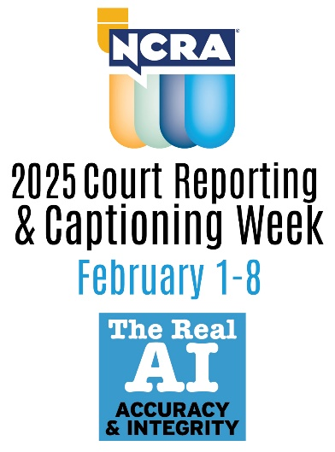
Dear (Name of student),

The 13th national Court Reporting & Captioning Week, hosted by the National Court Reporters Association (NCRA), is coming up and we need your help promoting this fantastic event and this exciting profession. The awareness week, happening Feb. 1-8, 2025, highlights the nationwide contributions of stenographic court reporters, CART captioners, and broadcast captioners to society. The week also showcases the many well-paying and flexible career opportunities available in the court reporting and captioning fields. This year NCRA is celebrating with the theme: AI: The Real Accuracy & Integrity.

To make national Court Reporting & Captioning Week a success, we need your help. NCRA has created resources to help you with promoting the event. Please visit the 2025 Court Reporting & Captioning Week resource page where you will find an array of downloadable and customizable materials to help you celebrate. Resources include press release templates, logos, posters, flyers, and much more.

During the week-long event NCRA members, state affiliates, court reporting schools, students, vendors, and others affiliated with the legal world come together to promote the stenographic court reporting and captioning professions and showcase why stenographic court reporting and captioning is the gold standard for making the most accurate record.

Please be sure to check the resource page regularly for even more promotional materials as they become available. We’re all really excited for the national Court Reporting & Captioning Week, and with your support, we know this event will be a great success. Please feel free to email me with any questions that you might have.

Sincerely,

(Name of program director)

