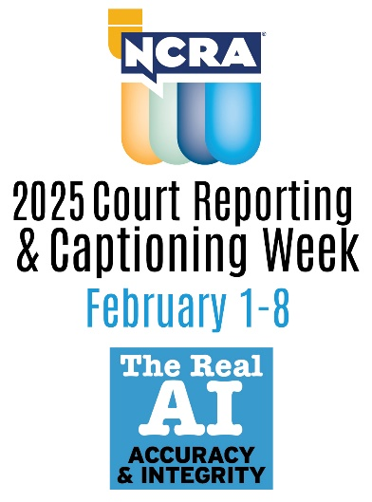
2025 Court Reporting & Captioning Week celebrates

Feb. 1-8 will highlight The Real AI: Accuracy & Integrity

RESTON, Va. – Feb. 27, 2025 - The nationwide 2025 Court Reporting & Captioning Week, sponsored by the National Court Reporters Association (NCRA), will be celebrated by court reporters, captioners, legal videographers, and others involved in the legal community. Feb. 1-8, 2025, will mark the event’s 13th year of observance with the theme: The Real AI: Accuracy & Integrity. NCRA is the country’s leading organization representing stenographic court reporters, captioners, and legal videographers.

To arrange an interview with a working court reporter, captioner, legal videographer, or current court reporting student, or to learn more about the lucrative and flexible court reporting or captioning professions and the many job opportunities currently available, contact pr@ncra.org.

During the week-long event, NCRA members, state affiliates, court reporting schools, students, vendors, and others affiliated with the legal world come together to promote the stenographic court reporting and captioning professions and showcase why stenographic court reporting and captioning is the gold standard for making the most accurate record. Throughout the week and throughout 2025, NCRA members will also reflect on how their unique set of skills has evolved over time from pen writing to today’s latest technology to capture the spoken word into realtime text.

“No matter how advanced, AI cannot replicate the human element when it comes to capturing the record,” said NCRA President Keith R. Lemons, FAPR, RPR, CRR, a retired official and freelance court reporter and firm owner from Spring Hill, Tenn.

"A live court reporter is present and has situational awareness of the emotions and innuendos of the subtlety of the spoken word, something AI cannot and will never be able to. That ability is a sacred and instinctual ability and one that no man-made system can ever replace. Stenographic court reporters and captioners are the epitome of these abilities.”

To help mark the week, NCRA offers members, state affiliates, court reporting schools, and others access to a 2025 Court Reporting & Captioning resources page that provides a catalog of customizable press release templates, media advisories, social media messages, information about securing official proclamations, videos, and more.

“Throughout the week our members will be issuing press releases announcing the week to their local media outlets, participating in career fairs at local high schools, showcasing what steno is at state or local courthouses, hosting Veteran History Project events, obtaining an official proclamation recognizing the week and the profession by state and local leaders, and more,” Lemons added.

“By participation in this week-long celebration, our members will collectively let the world know about this hidden gem of a profession and the vast opportunities it offers, no matter whether steno is being used to capture the official record or to provide access to vital information, entertainment, education, or more to someone who is deaf or hard of hearing,” he added.

Court reporters and captioners rely on the latest in technology to use stenographic machines to capture the spoken word and translate it into written text in real time. These professionals work both in and out of the courtroom recording legal cases and depositions, providing live captioning of events, and assisting members of the deaf and hard-of-hearing communities with gaining access to information, entertainment, educational opportunities, and more.

If you’re looking for a career that is on the cutting-edge of technology, offers the opportunity for work at home or abroad, like to write, enjoy helping others, and are fast with your fingers, then the fields of court reporting and captioning are careers you can explore at NCRA/discoversteno.org.

The NCRA A to Z® Intro to Steno Machine Shorthand program, a free online six-week introductory course, lets participants see if a career in court reporting or captioning would be a good choice for them. The program is an introduction to stenographic theory and provides participants with the opportunity to learn the basics of writing on a steno machine. There is no charge to take the course, but participants are required to have access to a steno machine or an iPad they can use to download the iStenoPad app.

About NCRA
The National Court Reporters Association (NCRA) has been internationally recognized for promoting excellence among those who capture and convert the spoken word to text for more than 125 years. NCRA is committed to supporting its more than 12,000 members in achieving the highest level of professional expertise with educational opportunities and industry-recognized court reporting, educator, and videographer certification programs. NCRA impacts legislative issues and the global marketplace through its actively involved membership.

Forbes has named court reporting as one of the best career options that do not require a traditional four-year degree. The U.S. Bureau of Labor Statistics reports that the court reporting field is expected to be one of the fastest areas of projected employment growth across all occupations. According to 247/WallSt.com, the court reporting profession ranks sixth out of 25 careers with the lowest unemployment rate, just 0.7 percent. Career information about the court reporting profession — one of the leading career options that do not require a traditional four-year degree — can be found at NCRA DiscoverSteno.org.

