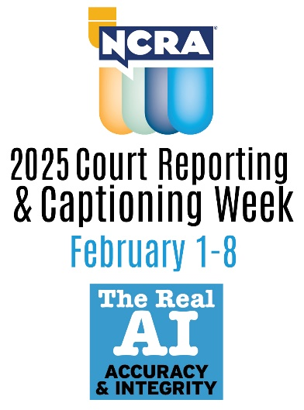
NCRA is celebrating the 13th National Court Reporting & Captioning Week Feb.1-8. 2025, and is using the theme: AI: The Real Accuracy & Integrity. This week serves as a nationwide effort to highlight that AI cannot, nor ever should, replace a live stenographic court reporter or captioner as their skills are the gold standard of the industry. Also celebrated and showcased throughout the week will be the contributions of stenographic court reporters and CART and broadcast captioners to society and the growing career opportunities that exist in the court reporting and captioning fields.

To make National Court Reporting & Captioning Week a success, we are asking for your support. Please share information about our upcoming awareness week and your endorsement of the court reporting and captioning professions. Not sure what to say? Below are examples of a few suggested social media posts:

- Court reporters, captioners, and court reporting schools around the country are making plans to celebrate 2025 National Court Reporting & Captioning Week Feb. 1-8. [State affiliate/Company name] is happy to show its support for these professions and help spread the word!

- Did you know? If you are interested in finding out if a career in court reporting or captioning is right for you, check out the NCRA A to Z® Intro to Steno Machine Shorthand program, a free six-week course that is available onsite and online. The course teaches participants how to write the alphabet in steno and offers the opportunity to see if the career path is for them.

(Before the event)
- @NCRA is celebrating 2025 Court Reporting & Captioning Week Feb. 1-8. Find more info here: NCRA.org/awareness #CRCW2025 (During the event)
- Happy national Court Reporting & Captioning Week! [State affiliate/Company] proudly supports these professions. NCRA.org/awareness #CRCW2025

However you decide to share your support, we ask that you include our hashtag (#CRCW2025) and/or the website (NCRA.org/awareness) for additional information and promotional materials.

We’re all excited for the launch of National Court Reporting & Captioning Week. With your support, we know this week and the entire year will be a great success. Please feel free to email NCRA at pr@ncra.org with any questions you might have or any info about how you are celebrating the week in 2025.

